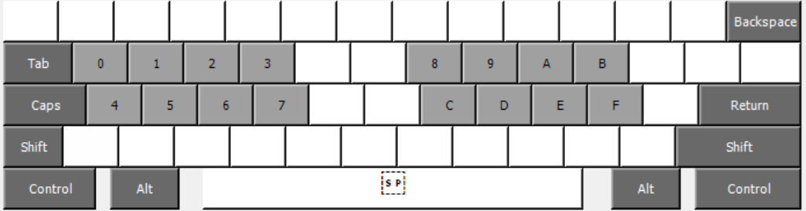
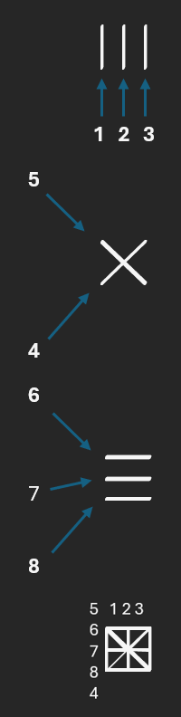
On the left, we see a schematic explaining the essential system of NIVLAC. It represents the binary of bytes in a visual style. Each glyph has a name derived from its binary value, as this table shows.
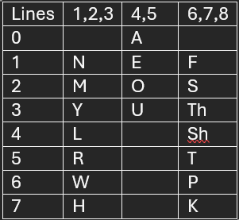
On the bottom, we see the layout of SMAK. It’s designed to type the possible range of 256 bytes as efficiently as possible. This means the first key press is lines 1-4 and the second lines 5-8. SMAK2 is like a normal keyboard with unhelpful keys removed.

